**Tableau Document**

**Bar Graph-**

**1.** **Category and Sales**



This bar graph shows the main comparison between Category and Sales as shown in the red circle. And the shape of each bar shows the Profit from that category, the values on top of the bars show the sales, and the color shades of the bar show the Discount on that category shown in the yellow circle in the above diagram.

The right-side chart shows the types of graphs. And left side shows the columns in the dataset.

**2.Region and Sales –**

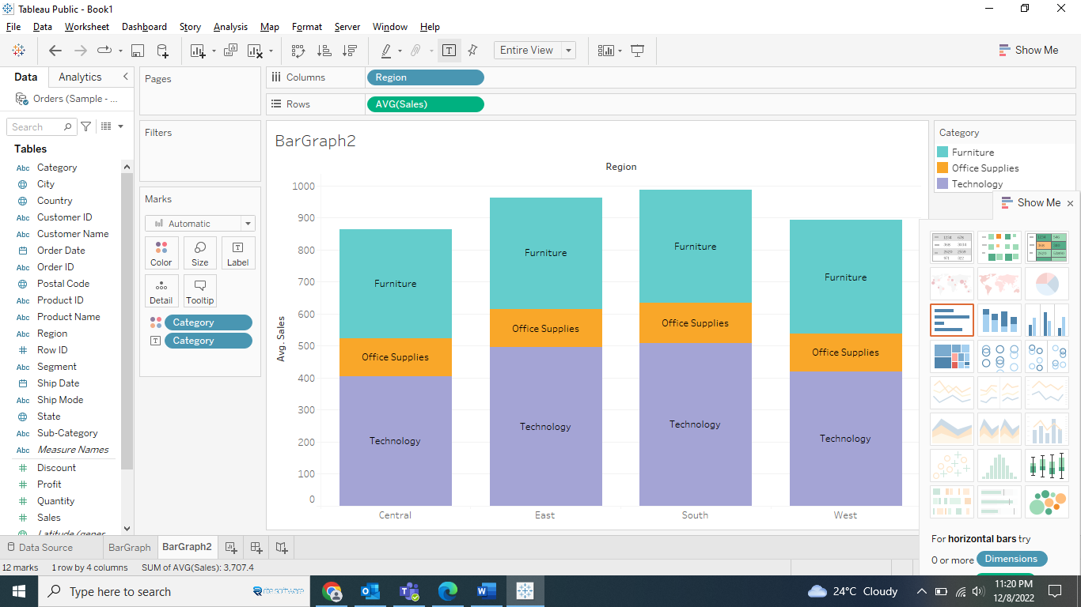

**3.Stack Bar graph-**

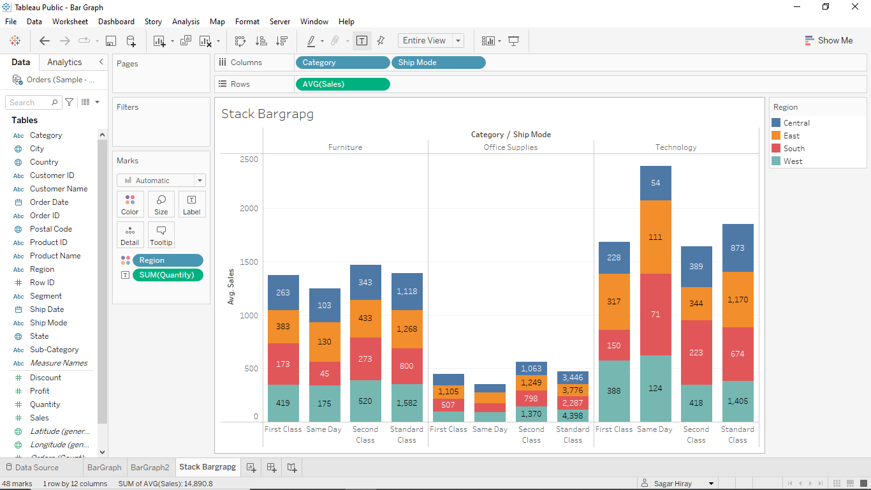

In this graph, two columns are taken on the x-axis and one column on the y-axis. The region is in the color section and the sum of quantity is in the label section.

The Technology category shoved the highest Avg Sales through Same Day Ship Mode, and The Office Supplies category shoved the lowest Avg Sales through Same Day Ship Mode.

**Line Graph-**

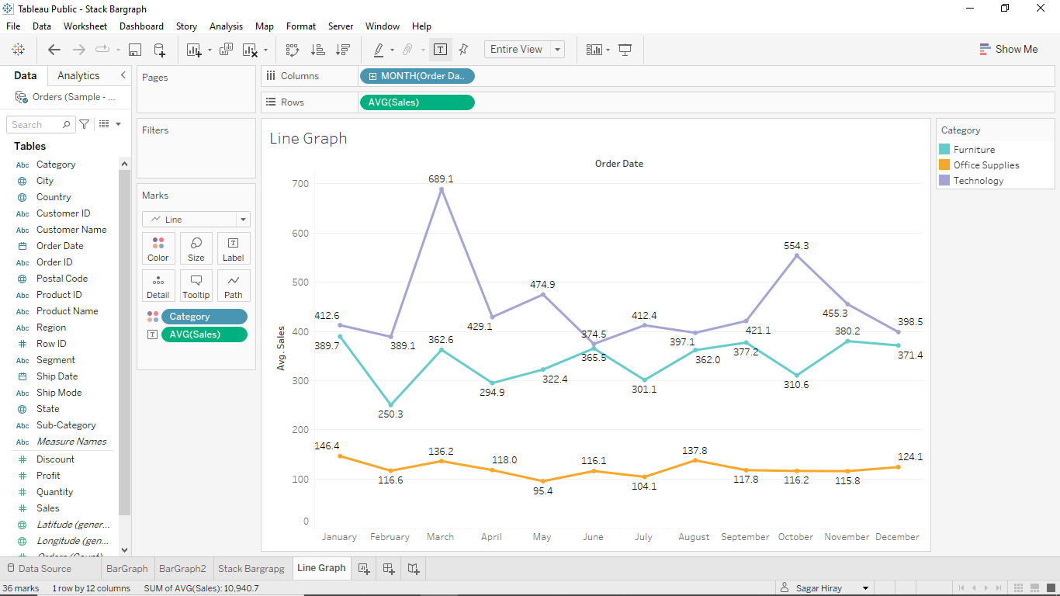

In this Line Graph, we can see the Technology Category has maximum Avg Sales compared to other Categories and the Office Supplies has less Avg Sales but much constant in nature.

**2.**

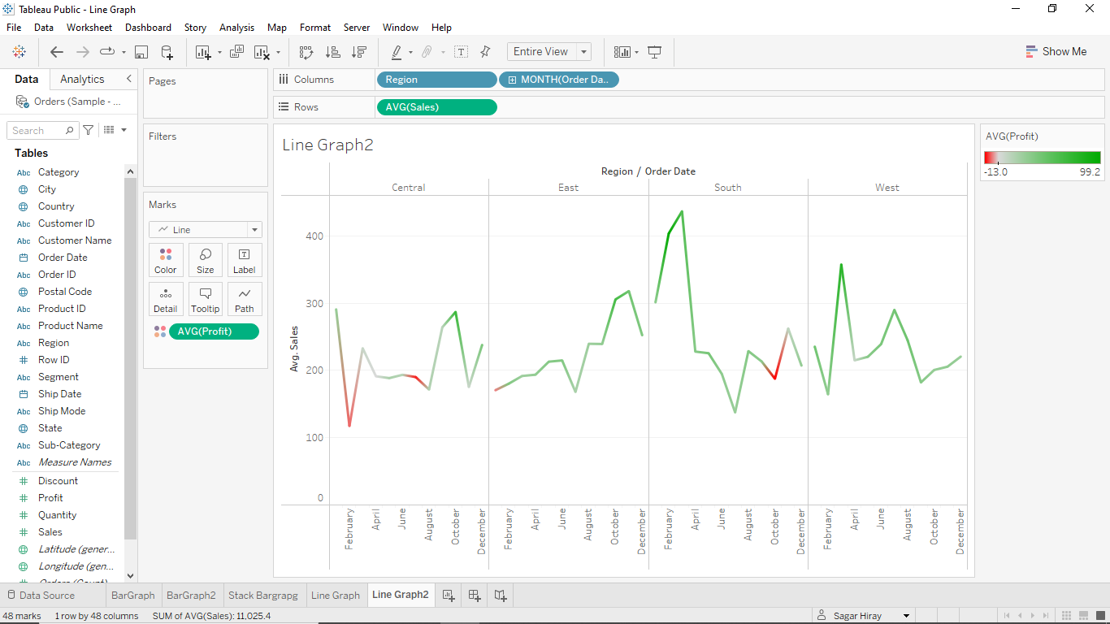

3.

**Pie Chart-**

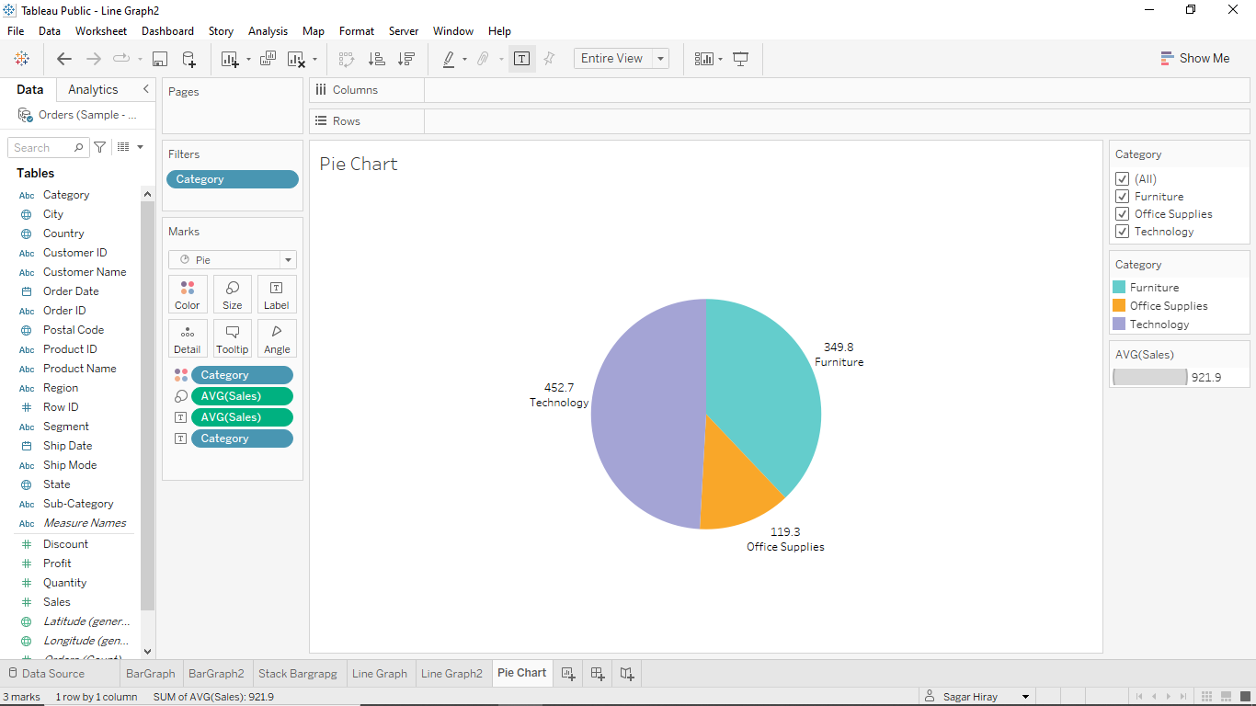

This Pie Chart shows the Avg Sales by Category wise.

**Visual Table-**

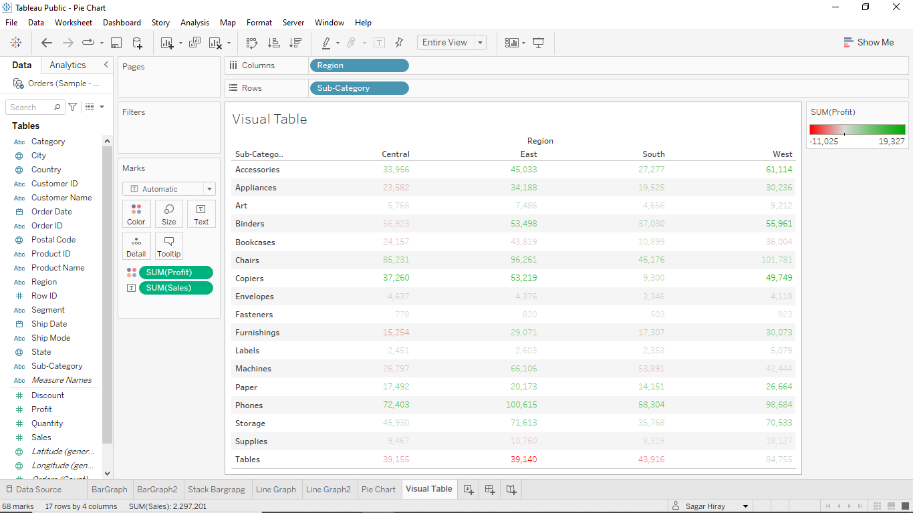

This table shows the profit and loss in Region by Sub-Category wise.

**Bubble Graph-**

This bubble graph shows all the cities as a circle with different colors and shapes of the circle shows the profit comparison.

**Tree Map-**

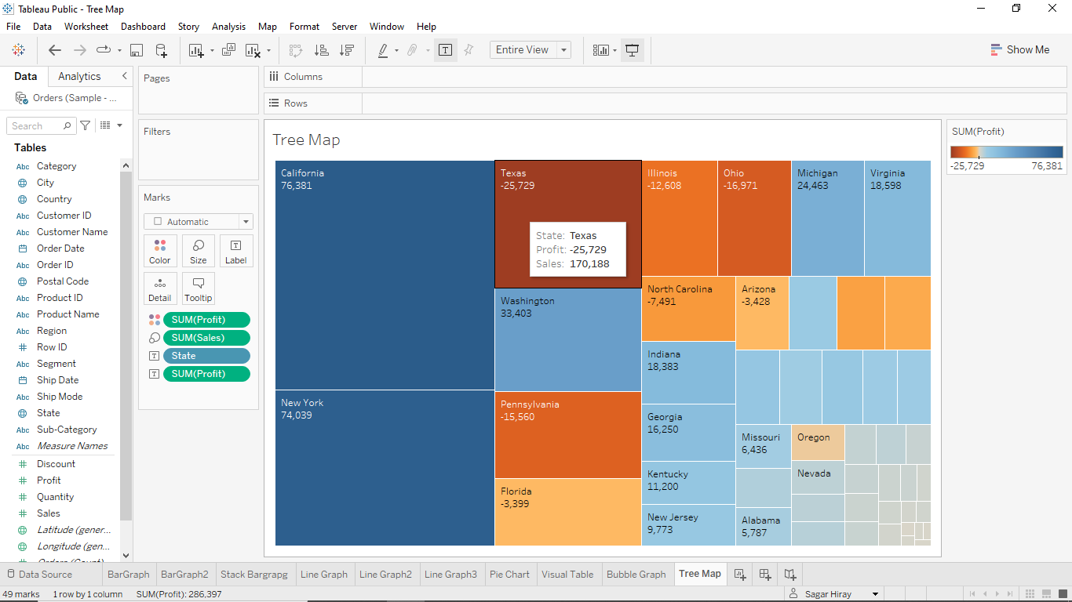

The squares show the sum of profit and the colors show the sum of profit with respect to states.

**Area Graph-**

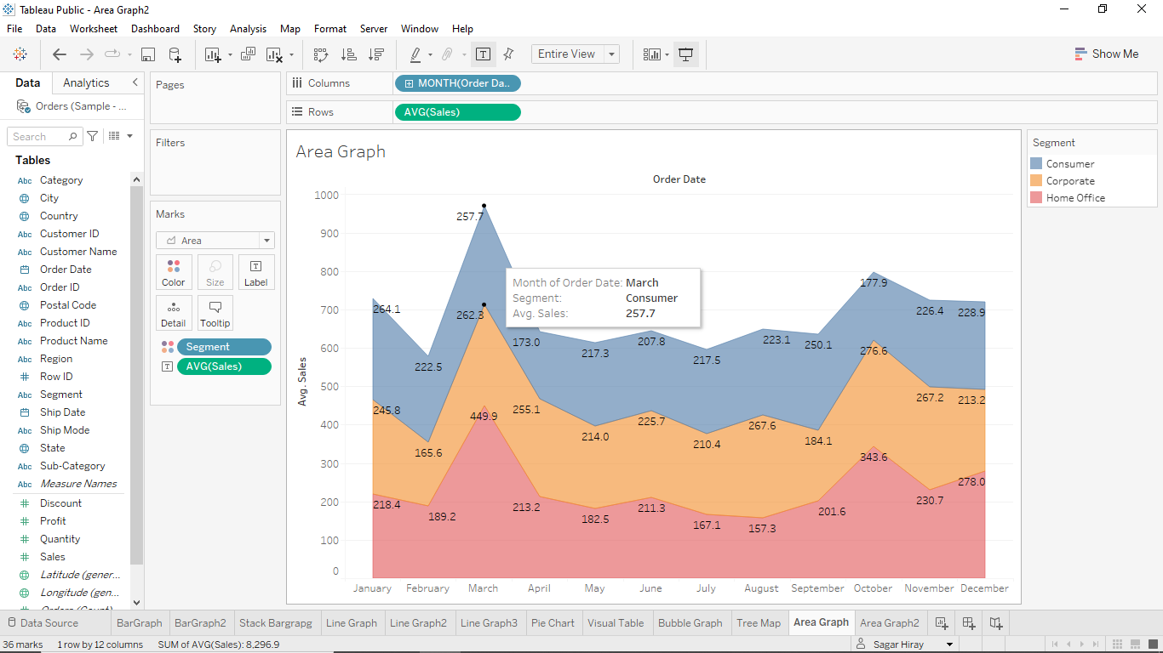

This graph shows the avg sales of segments per month wise, the main difference in the area graph is that after the second area it starts measuring from the end of the previous area.

**2.**

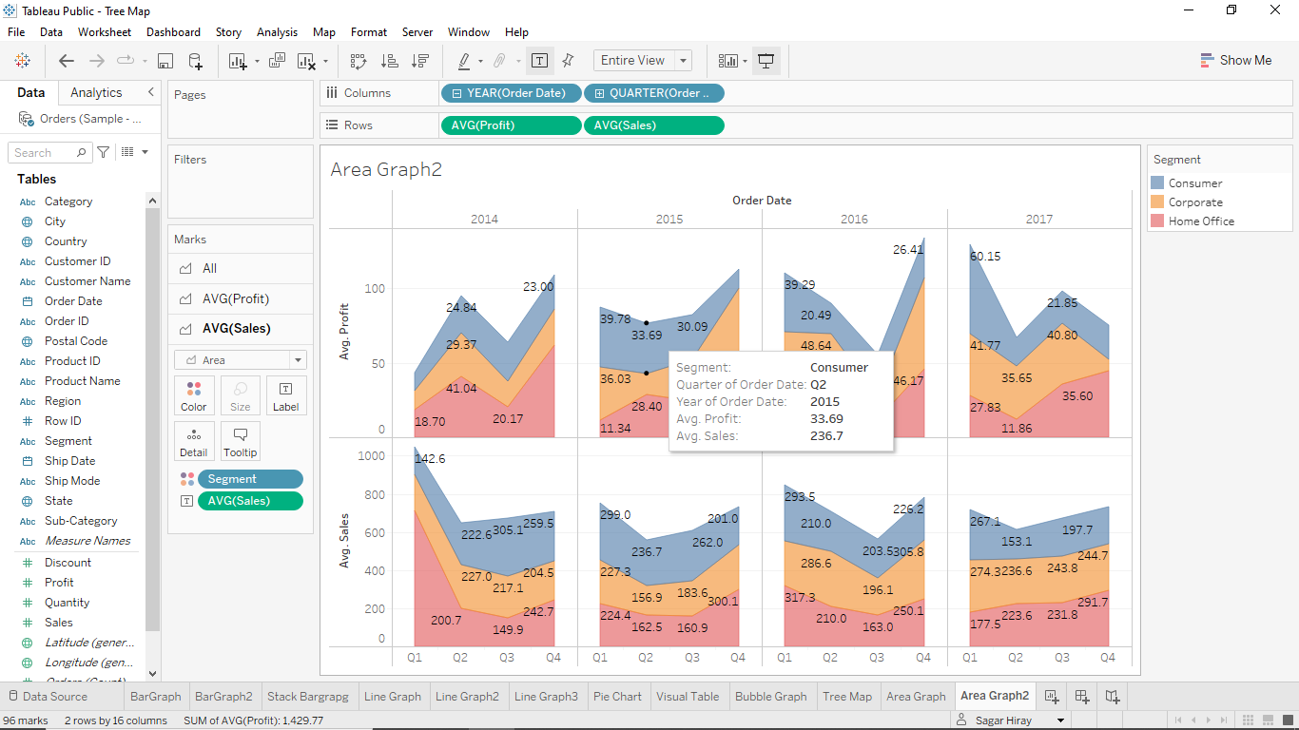

**Histogram-**

The histogram is continuous in nature like the x-axis shows the continuous range.

This histogram shows the relationship between Quantity Range (Bin with size 2) and Quantity Count.

**Waterfall Chart using Gantt Bar-**

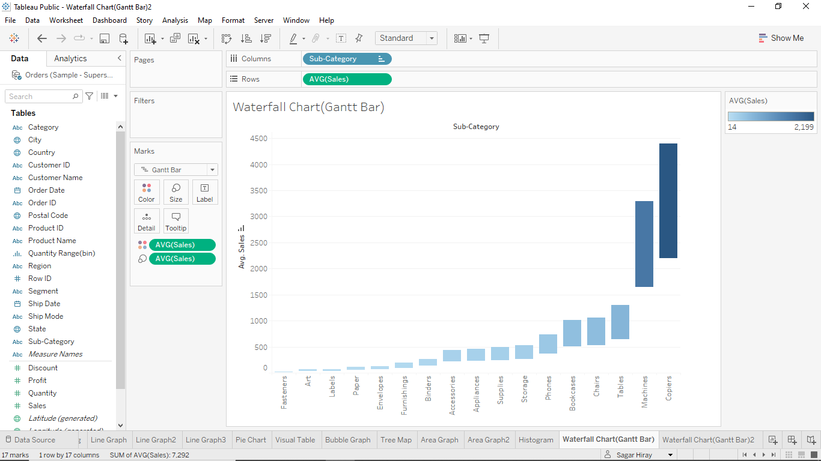

**2.**

**Bump Chart-**Bump chart is used to campier the parameters and give the rank respect to time.

Let’s take the order date on x-axis and avg sales on y-axis and region in the color section.

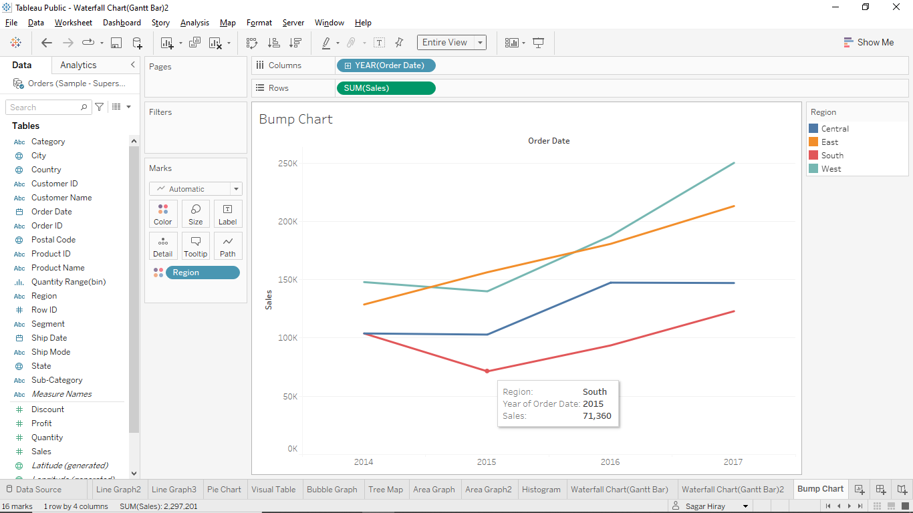

Now click AVG(Sales) and over the cursor on ‘Quick table Calculation’ and click on ‘Rank’.

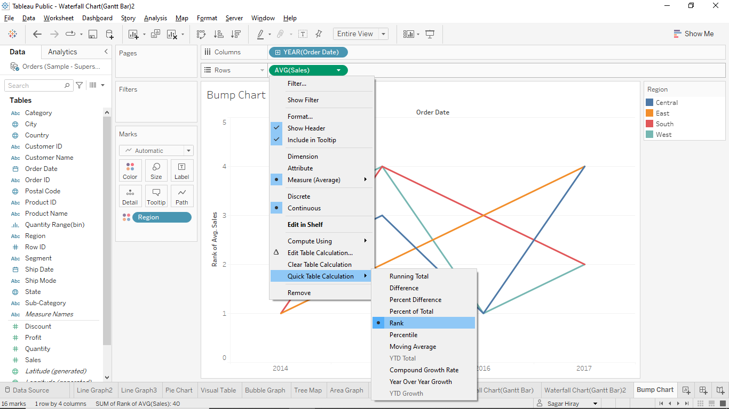

And last click AVG(Sales) and over the cursor on ‘Compute Using’ and click on ‘Region.

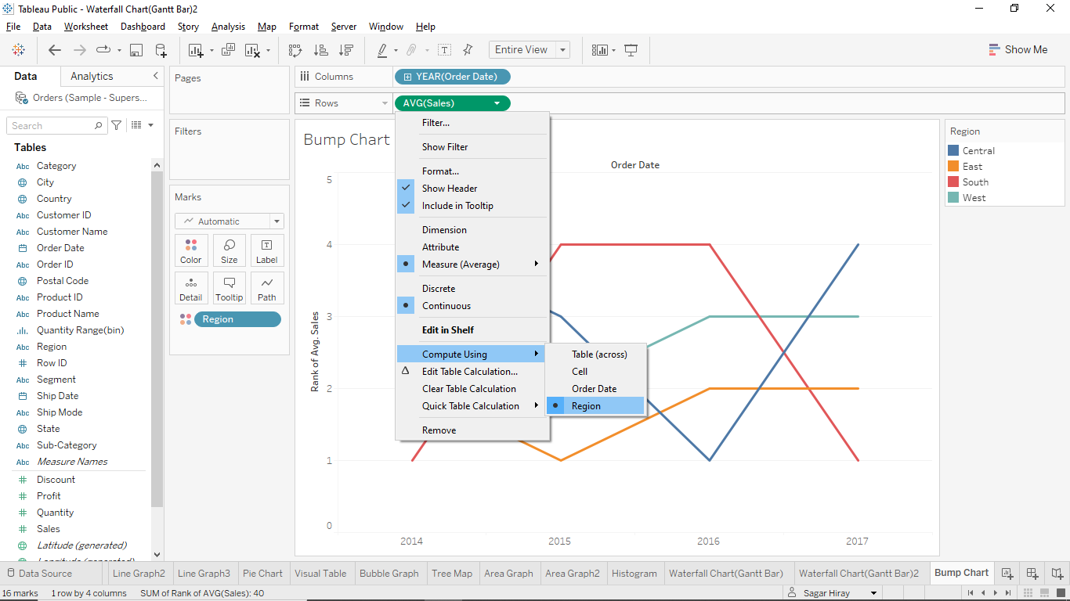

And this is the graph showing the rank of the region every year with respect to avg sales.

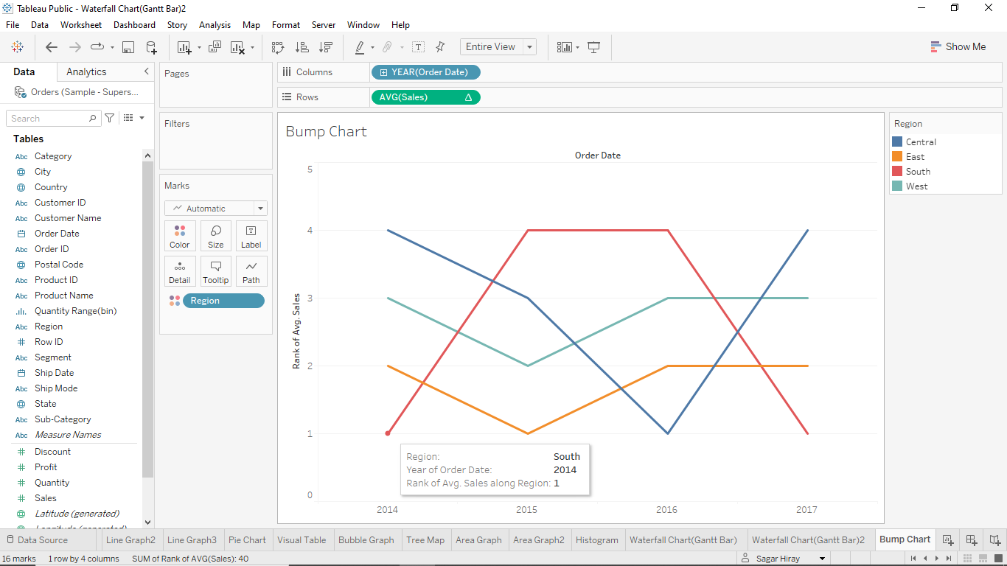

**Word Cloud-**

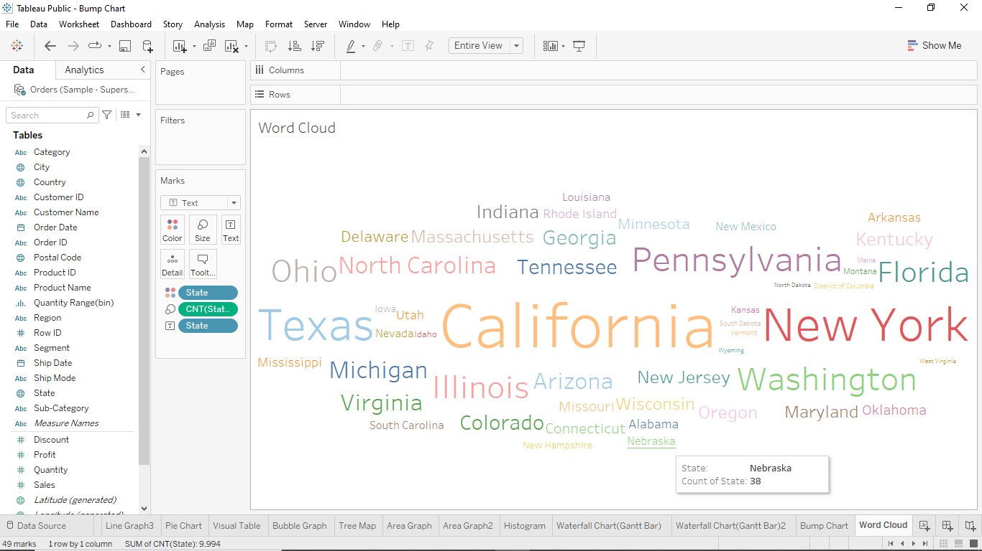

This is the word cloud with respect to the states. The size of the word depends on the frequency of the state in the data.

**Funnel Chart-**

This funnel shape chart shows the sales of the different categories in the form of shapes.

**Pareto Chart-**

This graph compares two parameters at the same time using the Dual axis. Line graph shows the profit, and the bar graph shows the sales.

**Forecasting-** Using the Tableau Analytics feature we can predict the futures values.

This graph shows the sales for the respective year and shows the forecasted sales for the next two years.

**Dashboard-** This is one of the features of the tableau that shows multiple graphs in a single window is called the Dashboard.

